College of Information Technology
Department of Computer Science
ITCS285 Database Management Systems Second Semester 2025/2026

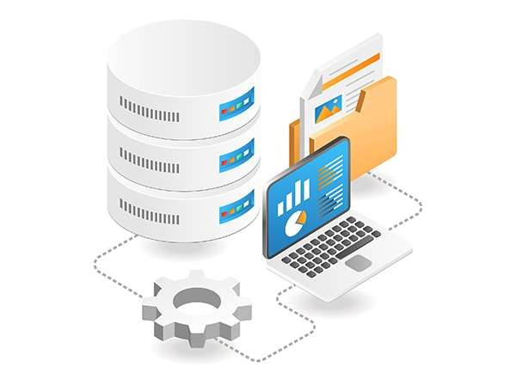

ITCS285 FINAL PROJECT REPORT
Name: HUSSAIN ALI H. ALI ID: 202405120 Section: 05
Name: DANIA AHMED ID: 202400485 Section: 05

Research supervised by Dr. Mohsin Rouached

Research Publication Tracker
Database Management System

INTRODUCTION:
1.1 PROJECT OVERVIEW:
The Research Publication Tracker is a database management system project designed to organize and manage university research publications. The system focuses on storing information about researchers, departments, publications, publication venues, keywords, and authorship details.

Universities produce many research outputs every year, including journal articles, conference papers, book chapters, and reports. Without a structured database, it can become difficult to track who wrote each publication, which department produced it, where it was published, and what topics it covers. This project solves that problem by designing a relational database that stores publication data in a clear, organized, and searchable way.
The main goal of this project is to apply database design concepts learned in ITCS285, including entity identification, relationships, constraints, normalization, relational schema design, SQL table creation, sample data insertion, and useful SQL query writing.

1.2 PROJECT OBJECTIVES:
- Design a database system for tracking academic research publications.
- Store researcher information such as name, email, role, and department.
- Store department information such as department name and college.
- Store publication information such as title, year, type, DOI, abstract, and venue.
- Track publication venues such as journals, conferences, and publishers.
- Support many-to-many relationships between researchers and publications.
- Store the order of authors for each publication.

- Support many-to-many relationships between publications and keywords.
- Apply primary keys, foreign keys, unique constraints, and domain constraints.
- Write SQL statements to create tables and insert sample data.
- Write SQL queries that produce useful reports about publications.

SYSTEM REQUIREMENTS:
  - SYSTEM SCOPE:
The system is designed as a relational database that organizes research publication data in a structured and efficient way. It reduces redundancy and allows fast retrieval of academic information through relationships between researchers, departments, publications, and related metadata.
Area | Description
Researchers | Stores information about faculty members, students, and external researchers.
Departments | Stores the academic department and college connected to each researcher.
Publications | Stores research output details such as title, year, type, DOI, and abstract.
Venues | Stores information about where publications are published, such as journals or conferences.
Keywords | Stores topic keywords that help classify and search publications.
Authorship | Connects researchers to publications and records author order.
Publication  Keywords | Connects publications to their related keywords.

  - REQUIREMENT GATHERING:
These requirements were identified based on the need to manage academic research data in a university environment in a structured manner:
- Researchers have an ID, full name, email, role, and department.
- Departments have an ID, department name, and college.
- Publications have an ID, title, publication year, publication type, DOI, and abstract.

- Venues have an ID, venue name, venue type, and publisher.
- Keywords have an ID and keyword text.
- A researcher can author many publications, and a publication can have many researchers.
- The order of authors must be stored for each publication.
- A publication must be linked to one publication venue.
- A publication can have many keywords, and a keyword can belong to many publications.
- Researcher emails must be unique.
- DOI values must be unique when available.
- The system should support searching publications by researcher, department, venue, year, or keyword.
- The system should support generating reports such as publications per researcher and publications per department.

ER DIAGRAM:
The ER diagram below shows the main entities in the system and how they are related to each other.

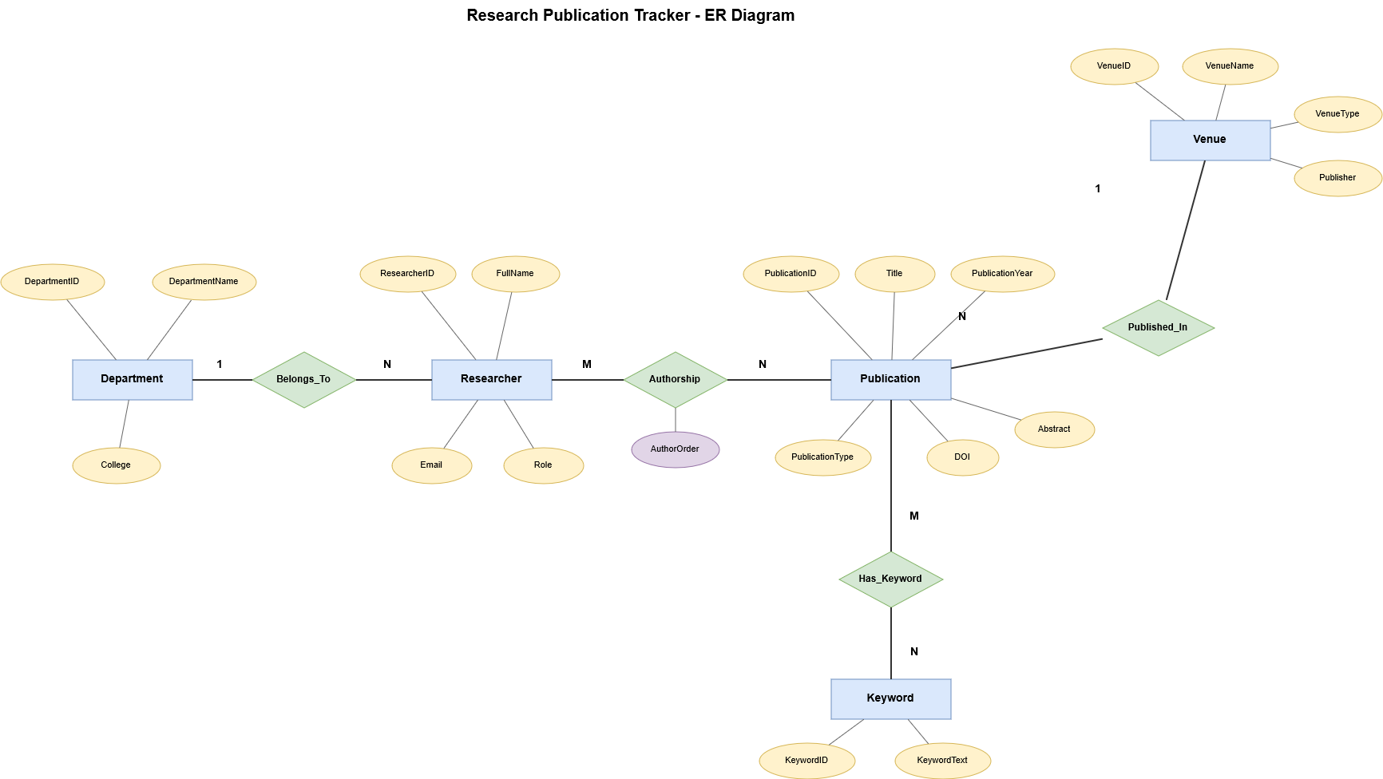

Figure 1: ER Diagram of Research Publication Tracker System



RELATIONAL SCHEMA:
The table below shows a relational database schema of the ER diagram above.
DEPARTMENT

Department(DepartmentID, DepartmentName, College)
Primary Key: DepartmentID

RESEARCHER

Researcher(ResearcherID, FullName, Email, Role, DepartmentID)
Primary Key: ResearcherID
Foreign Key: DepartmentID → Department(DepartmentID) Unique: Email

VENUE

Venue(VenueID, VenueName, VenueType, Publisher)
Primary Key: VenueID

PUBLICATION

Publication(PublicationID, Title, PublicationYear, PublicationType, DOI, Abstract, VenueID)
Primary Key: PublicationID
Foreign Key: VenueID → Venue(VenueID)
Unique: DOI

KEYWORD

Keyword(KeywordID, KeywordText)
Primary Key: KeywordID
Unique: KeywordText

AUTHORSHIP

Authorship(ResearcherID, PublicationID, AuthorOrder) Primary Key: (ResearcherID, PublicationID) Foreign Keys:
- ResearcherID → Researcher(ResearcherID)
- PublicationID → Publication(PublicationID)

PUBLICATIONKEYWORD

PublicationKeyword(PublicationID, KeywordID) Primary Key: (PublicationID, KeywordID) Foreign Keys:
- PublicationID → Publication(PublicationID)
- KeywordID → Keyword(KeywordID)



DBMS SYSTEM:
This section presents the implementation of the Research Publication Tracker database using MySQL. The relational schema was translated into SQL to create the required tables and define all relationships and constraints.

MySQL was used for this project due to its reliability and support for relational database features. The following figures show the creation of the tables and the insertion of sample data into the system. The implementation begins with the creation of the database tables using SQL statements.
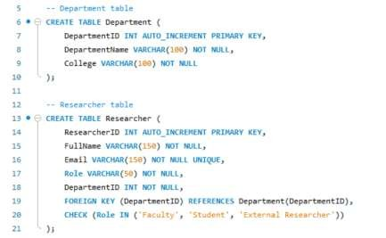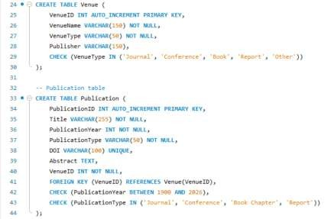

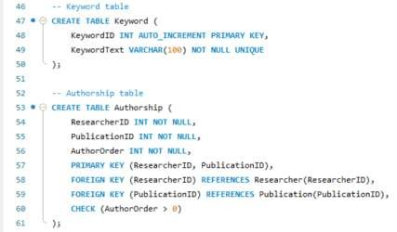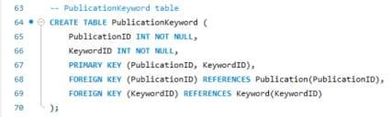

After creating the tables, sample data was inserted and the populated relations are shown in the following figures.

The Department Relation

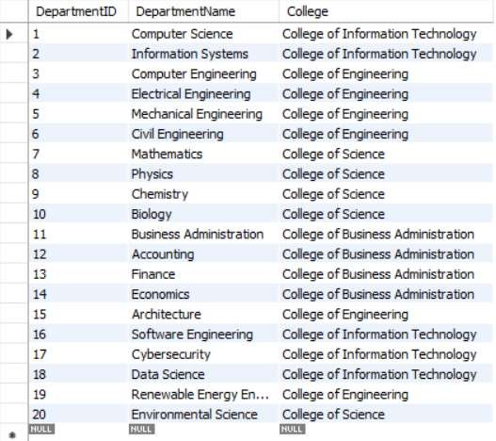

The Researcher Relation
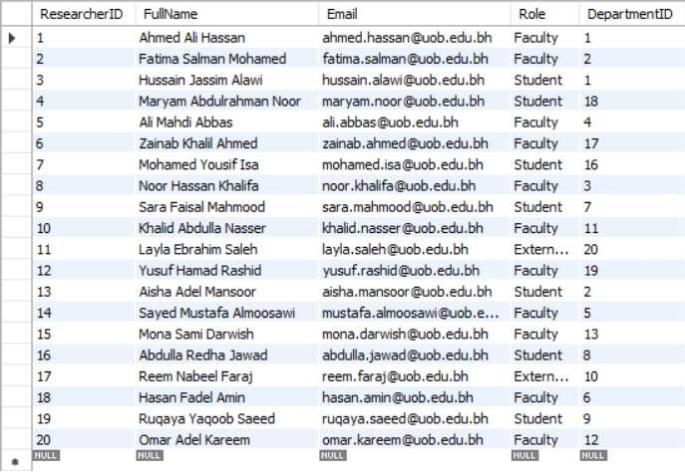



The Venue Relation
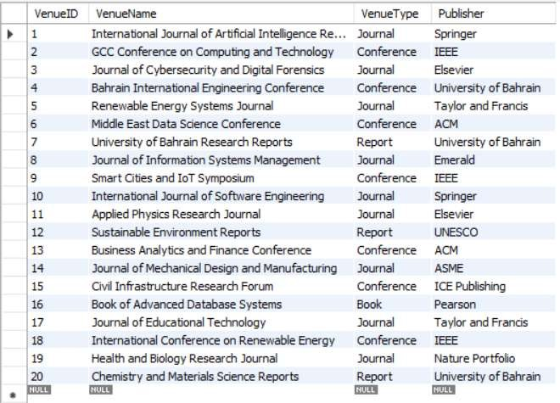

The Publication Relation
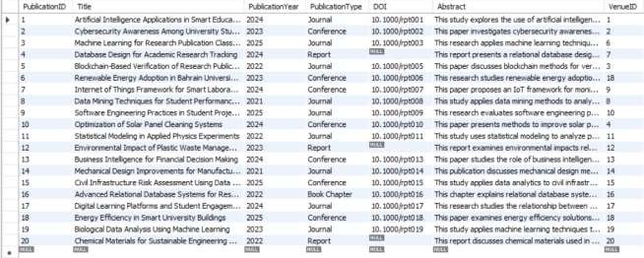

The Keyword Relation

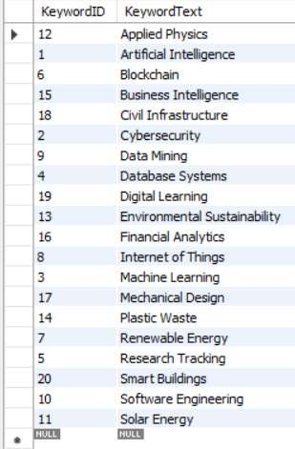

The Authorship Relation
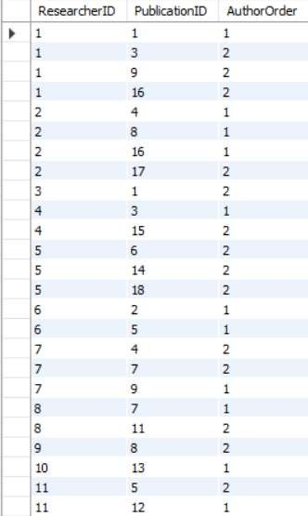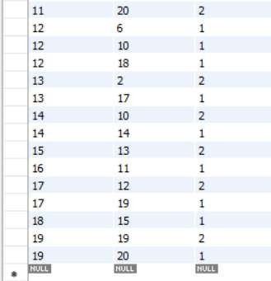



The PublicationKeyword Relation
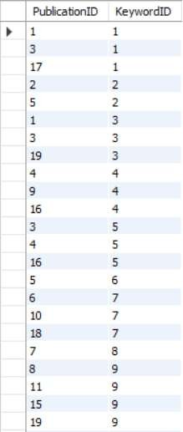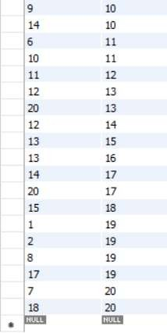

QUERIES FOR THE SYSTEM:

The following SQL queries were executed on the Research Publication Tracker database to retrieve and analyze information from different tables.
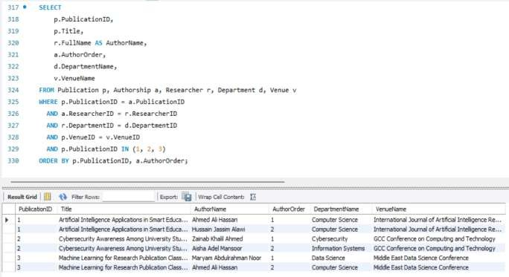

Query 1:
Publications with Authors, Departments, and Venues

Purpose:
This query lists selected publications with their authors, author order, department, and publication venue. It
demonstrates a multiple
-
table join.

Query 2: Publications Newer Than the Average  Publication Year  Purpose: This query finds publications that were published after the average publication year in the database. It demonstrates a subquery.  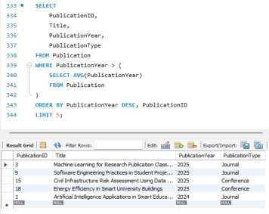 | Query 3: Number of Publications per  Department  Purpose: This query counts the number of distinct publications connected to each department. It demonstrates GROUP BY.  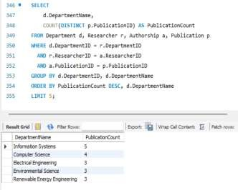
Query 4: Latest Publications Ordered by Year and  Title  Purpose: This query displays the newest publications first and sorts publications from the same year alphabetically by title. It demonstrates ORDER BY.  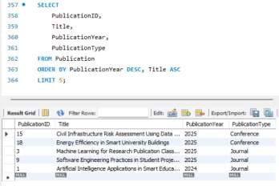 | Query 5: Researchers Who Have Not Authored  Any Publication  Purpose: This query finds researchers who do not appear in the Authorship table. It demonstrates NOT IN.  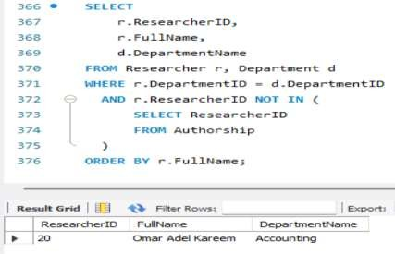

Query 6: Publications Related to Energy  Purpose: This query searches for publications that contain the word "Energy" in the title or abstract. It demonstrates LIKE.  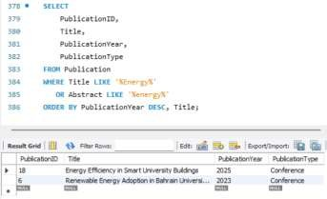 | Query 7: Overall Publication Year Statistics  Purpose: This query summarizes the publication years in the database. It demonstrates aggregate functions such as COUNT, MIN, MAX, and AVG.  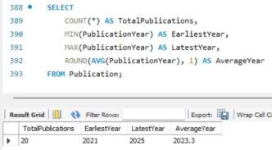
Query 8: Researchers with More Than Two  Publications  Purpose: This query lists researchers who authored more than two publications. It demonstrates HAVING.  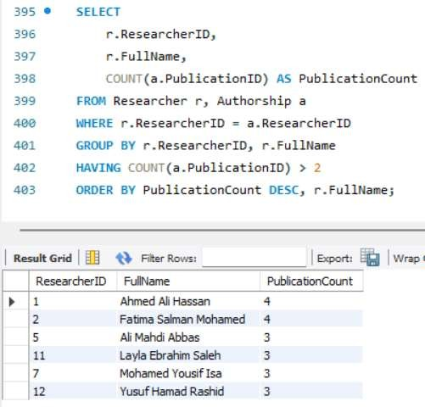 | Query 9: Publication Age in Years  Purpose: This query calculates the age of each publication using the project year 2026. It demonstrates a calculated field.  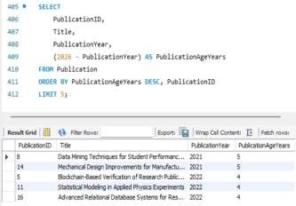

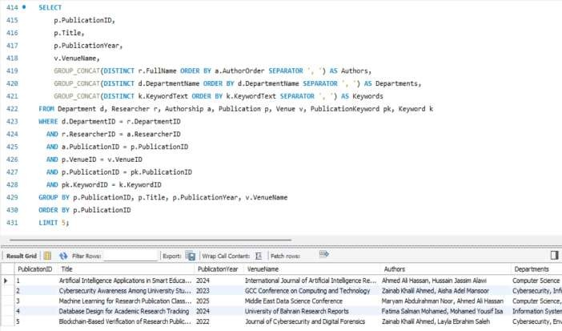
Query
10
:

Complete Publication Report

Purpose:
This query produces a detailed publication report showing publication, venue, authors, departments, and
keywords. It involves most of the database relations
.



CONTRIBUTIONS:
MEETING NO.1 | 8TH MAY 2026 | Discussed the project idea, identified the main system requirements, and planned the database entities and relationships.
MEETING NO.2 | 10TH MAY 2026 | Designed the ER diagram and converted it into the relational schema with primary keys and foreign keys.
MEETING NO.3 | 14TH MAY 2026 | Implemented the database in MySQL, created the tables using SQL, inserted sample data, and tested SQL queries.
MEETING NO.4 | 15TH MAY 2026 | Reviewed the project report, organized screenshots and query results, checked formatting, and prepared the final submission.

Member Name | Contribution
Hussain Ali H. Ali | Database implementation, SQL queries, sample data insertion
Dania Ahmed | Report writing, formatting, ER diagram organization, testing queries

CONCLUSION:
The Research Publication Tracker database system was successfully designed and implemented using MySQL. The project applied important database concepts such as ER modeling, relational schema design, constraints, normalization, and SQL query processing. The system allows efficient storage and retrieval of publication-related information and demonstrates the practical use of database management systems in academic environments.



END OF REPORT

